**Abstract**

An open-source and mainly 3-D printable hand prosthesis is to be developed by a team of five Mechanical Engineering seniors in a student-driven design project. The device will combine the technologies of existing 3-D printed hands with the concept of granular jamming to maintain a wide range of grips at a fraction of the cost of existing prostheses. It will allow for performance of relatively low strength, high dexterity, household tasks. To meet this goal, a background has been established (including research on amputation, human mechanics, and current state-of-the-art technologies), original research has been performed (including research on hand usage, granular jamming effectiveness, and analyses of joint stress, fatigue strength, and manufacturability) and resulting designs have been generated and compared, resulting in a finalized plan for product design. In future work, this design will be manufactured, working out minor adjustments, and the resulting prosthesis will be tested.

**Electrical Considerations**

From an electrical standpoint it is important to note that the pump and servo motors require different source voltages. The battery supplies 12 volts, which is suitable for the pump but not for the servo motors, which require 6 volts. As a result, converters will have to be included to account for this change in voltage. Aside from this the project is relatively simple from an electrical standpoint, with only four motors, one pump, one motor-controlled valve, and four Hall Effect sensors.

A simplified schematic of the electrical system can be seen here:

(I am consulting with someone on how exactly this should look, since I don’t know much about electronics, and should have it ready by around the middle of the week)

**Control Considerations**

As can be seen in the electrical diagram above, the Hall Effect sensors will receive power from the Ardunio, as will the servo motors. The pump will be powered directly from the battery and controlled via the Ardunio. By using Hall Effect sensors and springs in the motor mounts, finger pressure can be measured as a displacement.

The principle behind this design is quite simple. As the finger contacts an object, that object will resist the finger’s closing. As a result the cable will begin to offer more resistance to getting reeled in by the motor. If the motor is free to slide, it begins to pull itself forward, toward the hand. By mounting the motor with a spring in the front, it will be pushed to the back of its housing when in a neutral state, but when the finger contacts an object, the motor will pull itself forward, compressing the spring. The more force exerted at the finger, the more the motor will pull forward. By placing a sensor at the back of the motor housing (consisting of a magnet attached to the motor via a small piece screwed to the motor wings, and a Hall Effect sensor at a stationary point of the forearm), distance that the motor has been pulled forward can be sensed via the change in measured magnetic field (measurements will be higher at a neutral state, and drop when the finger is pressing into an object). This means that pressure can be reasonably measured, accurately and inexpensively, while having absolutely no electronic components in the hand itself.

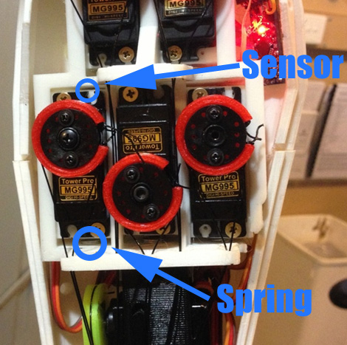**Figure xxx: Proposed sensor setup. (Source 1).**

This design has the benefit of making the hand itself more robust (since there will be no wires potentially getting crimped in moving joints) with more room for soft pads. It will also make the hand water resistant, which is greatly useful for a number of household tasks (for example, if activities, such as preparing food, require sanitation, the hand can simply be washed carefully with household soap). Finally, keeping all the active components of the design (rather than the passive parts such as the wires and the jamming pad itself) contained within the forearm means that they are easily accessible for replacement or repair, something that cannot be said of sensors that snake their way through many moving parts.

As far as the pump control is concerned, there will be two ways to activate the pump and engage the granular jamming pad. The first is to add a simple program that states when enough fingers are in contact with an object (as determined by the Hall Effect sensors), the vacuum will automatically activate. The second is to allow the user to choose to activate the pump, either by physical button or via Bluetooth command. Having the first system in place allows the granular jamming pad to engage and improve on grip that the user is already exerting. Having the second system in place allows the user to have more control over the granular jamming pad, making it useful in situations where items are too small or fragile to manipulate with the fingertips. Instead the user can simply orient the granular jamming pad and run the pump themselves.

Both of these methods will be supported. Whether the second method will be supported via a button or Bluetooth command (or both) will be ironed out during final development. Both procedures require very minor design adjustments that will not alter fundamental design.

One other aspect of supporting Bluetooth is that it would allow the user much more control of the prosthetic in general. Going too far into programming and control of the device is probably beyond the scope of the project, but since it is open source, users can build more and better control interfaces onto the team’s established control framework. Bluetooth support would allow the user to seamlessly switch between different closing speeds for the fingers, different pressure sensitivities in the Hall Effect sensors, and allow for better control of the granular jamming pad. Therefore Bluetooth capability is being strongly considered in the final design, and even though it may or may not be implemented by the team, the prosthetic will be designed around being able to support this method of control.

**Safety Considerations**

As far as safety is concerned, nothing in the design is particularly dangerous. The pump is quite small, the motors do not exert enough force to injure someone, and the battery, while it does represent a small fire hazard, is designed to be safe (just think of how often one encounters the rechargeable battery in laptops, cars, etc without any risk to the user).

The only real issue is that the arm is not designed to be waterproof. While the hand is water resistant, if a large amount of water gets into the forearm it will damage the electronics. This risk can be mitigated by shrinkwrapping the Ardunio and insulating the wire contacts well (and possibly using waterproof servos) but the chances of fully waterproofing the arm are quite low and as a result it will never be appropriate to submerge it in water (even though the hand alone can be submerged with no issues). It will be however be reasonable to say that the hand can be made relatively water resistant, so that going out on a somewhat rainy day will not damage the electronics.

One other safety aspect that may be explored is the idea of adding a “kill switch”, making all electronics shut off. This might be an appropriate addition if certain problems are encountered as the hand is used, for example, if the hand closes around something and will not open, or if the pump is stuck continuously running. This kill switch would consist of a switch at the battery, flipping it will cut off all power to the Ardunio and electronics. This kill switch will be implemented if the prototype displays any issues with continuously running actuators (since adding it into the device will be trivial). The same function could also be controlled via Bluetooth (though if the device is not listening to commands, this may be useless).

**Professional Drawings/Assembly Models**

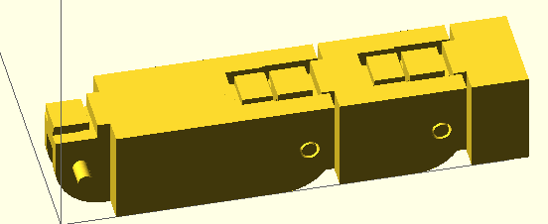 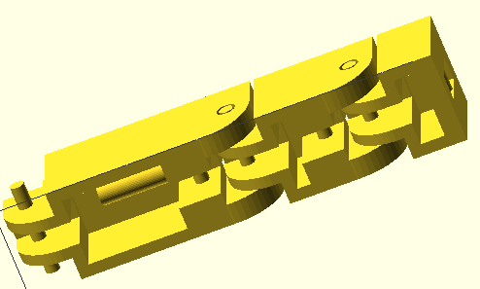

Here is the first iteration of the finger assembly in OpenSCAD.

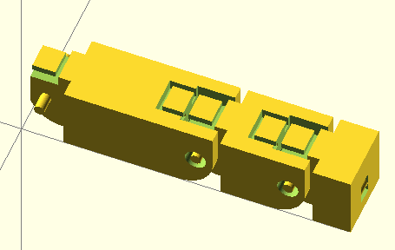 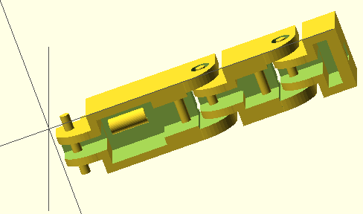

Here is the second iteration of the finger assembly in OpenSCAD. Joints are farther apart and bearing allowances are created.

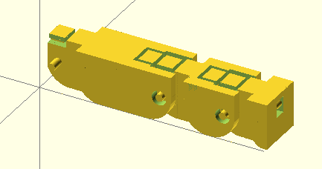 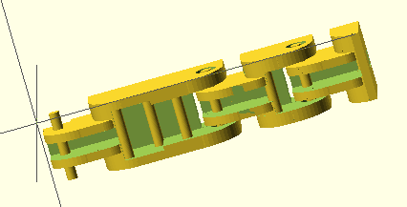

Here is the third iteration of the finger assembly in OpenSCAD. This finger has rounded, more spaced, joints to allow for a more realistic range of motion, and redesigned cable guides.

Since the design is to be 3-D printed, formal technical drawings with dimensions are rendered totally unnecessary. Normally a dimensioned drawing is needed in order for the device to be manufactured, but with 3-D printing, the model is simply exported as a .STL file and all dimensions are preserved when it is printed.

Therefore, in order to ensure that the modeled parts will fit correctly with motors, etc, we do not have to use technical drawings. Instead, we can simply model the motor itself and then subtract its shape from the printed model. As long as the motor model is correct (and a tolerance is included for the printer), the result will be a motor mount that always works, without having to change dimensions manually. Here is the motor file created for this process:

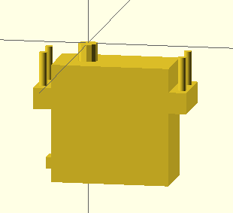

Interestingly, since OpenSCAD is script-based, this motor was written to call several arguments. This configuration is called by StandardServoMotor(true,2,true,.4), where the first argument denotes bolt direction (this is up), the second denotes hub type (this is the base metal hub), the third denotes where the module centers (this is centered at the hub), and the fourth represents printer tolerance (currently set at a fairly snug 0.4 mm).

Changing the configuration to StandardServoMotor(false,3,false,1) yields:

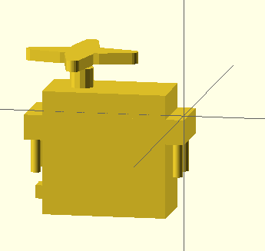

Note that the bolts are now facing down, the hub has changed to a different style, the motor now centers at the right-front corner, and though it is hard to see, the features are slightly larger.

Not sure what else to include for assembly models/drawings, does anyone have any suggestions? Is this enough?

**Source 1:** <http://www.thingiverse.com/thing:92352/>